

Advances Javascript



**MODULE:- 1**

1. Write a program to Show an alert?

Ans.

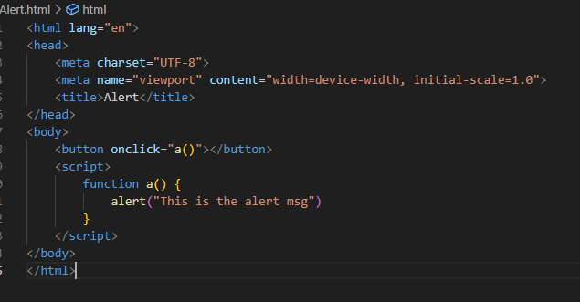

2. What will be the result for these expressions?

(1) 5>4

Ans. True

(2) "apple" > "pineapple"

Ans. False

(3) "2" > "12"

Ans. True

(4) undefined == null

Ans. True

(5) undefined === null

Ans. False

(6) null == "\n0\n"

Ans. False

(7) null === +"\n0\n"

Ans. False

3. Will alert be shown?

if ("0") { alert( 'Hello'); }

Ans.Yes, the ‘alert’ will be shown. It’s a non-empty string, it considered truthy. Therefore, the code inside the curly braces will be executed.

4. What is the code below going to output? alert( null || 2 || undefined );

Ans.The ‘alert’ function will display ‘2’. Because null and undefined refers empty string.

5. The following function returns true if the parameter age is greater than 18. Otherwise it asks for a confirmation and returns its result:

functioncheckAge(age)

{ if (age> 18)

{ return true; }

else {

// ...return confirm (‘did parents allow you?');

}

}

Ans.

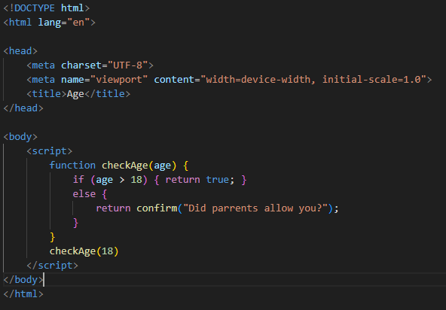

6. Replace Function Expressions with arrow functions in the code below:

Function ask(question, yes, no)

{ if (confirm(question))yes();

else no();

}

ask("Do you agree?", function()

{ alert("You agreed."); },

function() {

alert("You canceled the execution."); }

}

Ans. 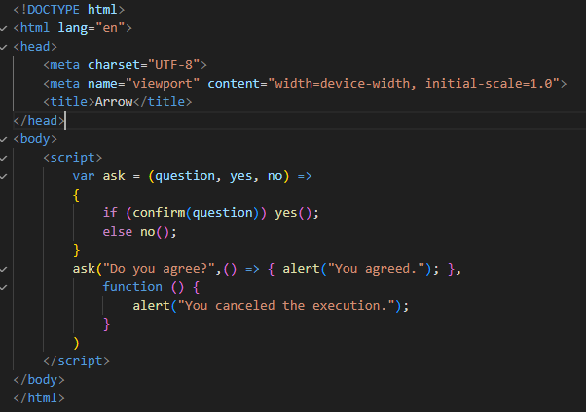

**MODULE: 2 (Data Types and Objects)**

1) Write the code, one line for each action

a) Create an empty object user.

Ans. let user = {};

b) Add the property name with the value John .

Ans. user.name = “john”;

c) Add the property surname with the value Smith.

Ans. user.surname = “smith”;

d) Change the value of the name to Pete .

Ans. user.name = “pete”;  
e) Remove the property name from the object.

Ans. delete user.name;

2) Is array copied? let fruits = ["Apples", "Pear", "Orange"]; // push a new value into the "copy" let shoppingCart = fruits; shoppingCart.push("Banana"); // what's in fruits? alert(fruits.length ); // ?

Ans. 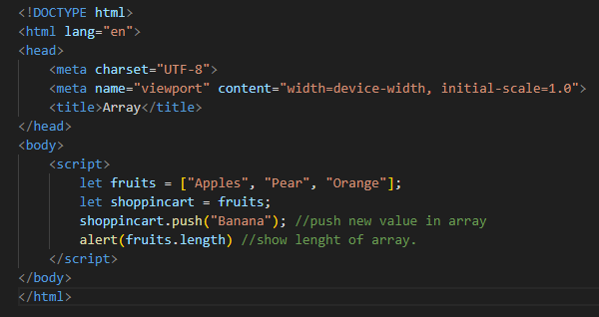

3) Map to names let john = { name: "John", age: 25 }; let pete = { name: "Pete", age: 30 }; let mary = { name: "Mary", age: 28 }; let users = [ john, pete, mary ]; let names = /* ... your code */ alert( names ); // John, Pete, Mary

Ans. 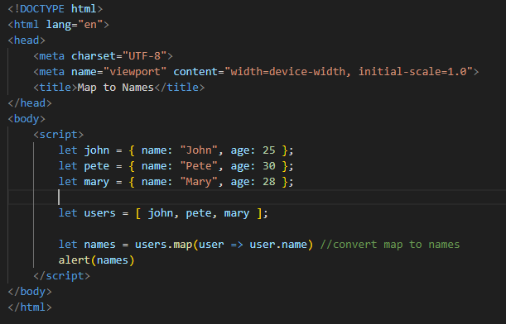

4) Map to objects let john = { name: "John", surname: "Smith", id: 1 }; let pete = { name: "Pete", surname: "Hunt", id: 2 }; let mary = { name: "Mary", surname: "Key", id: 3 }; let users = [ john, pete, mary ]; let usersMapped = /* ... your code ... */

/* usersMapped = [

{ fullName: "John Smith", id: 1 },

{ fullName: "Pete Hunt", id: 2 },

{ fullName: "Mary Key", id: 3 }

]

*/ alert(usersMapped[0].id ) // 1 alert( usersMapped[0].fullName ) // John Smith

Ans. 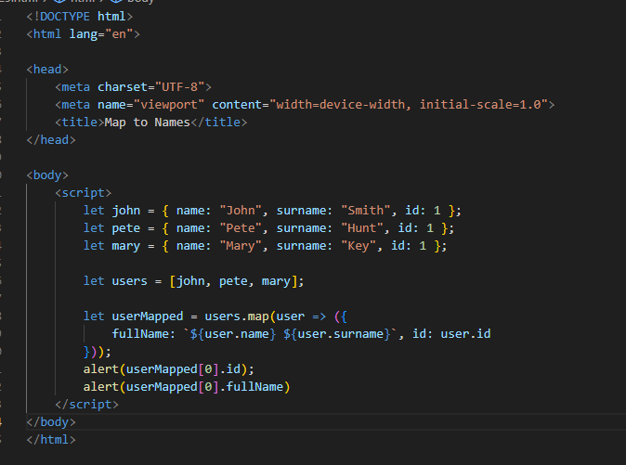

5) Sum the properties There is a salaries object with arbitrary number of salaries. Write the function sumSalaries(salaries) that returns the sum of all salaries using Object.values and the for..ofloop.If salaries is empty, then the result must be 0.

let salaries = {

"John": 100,

"Pete": 300,

"Mary": 250

};

alert(sumSalaries(salaries) ); // 650

Ans. 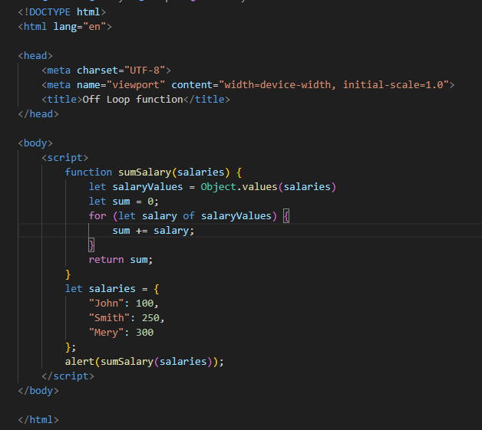

6)Destructuring assignment We have an object: Write the Destructuring assignment that reads:

a) Name property into the variable name.

b) Year’s property into the variable age.

c) isAdmin property into the variable isAdmin (false, if no such property)

d) let user = { name: "John", years: 30};

Ans.

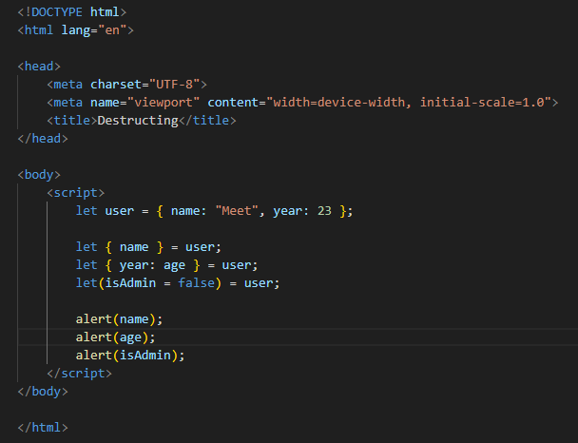

7) Turn the object into JSON and back Turn the user into JSON and then read it back into another variable.

user = { name: "John Smith", age: 35};

Ans.

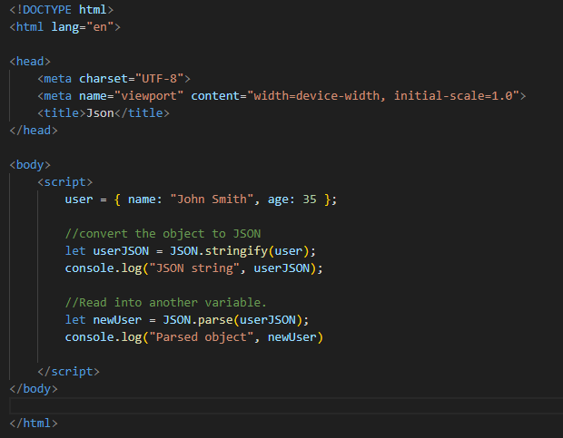

**MODULE: 3 (**Document, Event and Controls**)**

1. Create a program to hide/show the password

Ans.

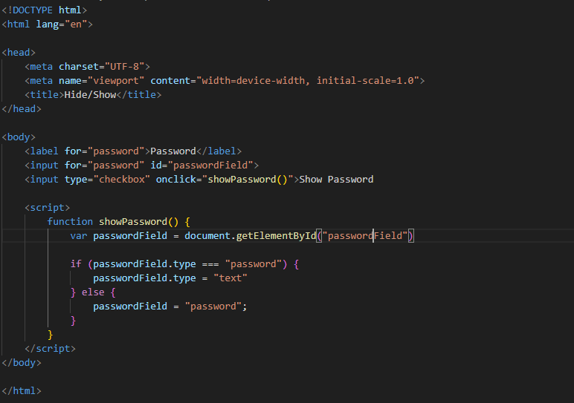

2. Create a program that will select all the classes and loop over and whenever i click the button the alert should show

Ans.

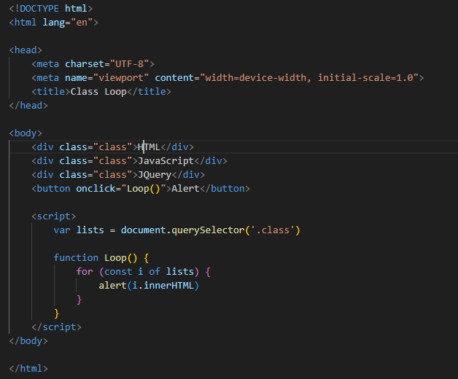

3. Create a responsive header using proper JavaScript

Ans. 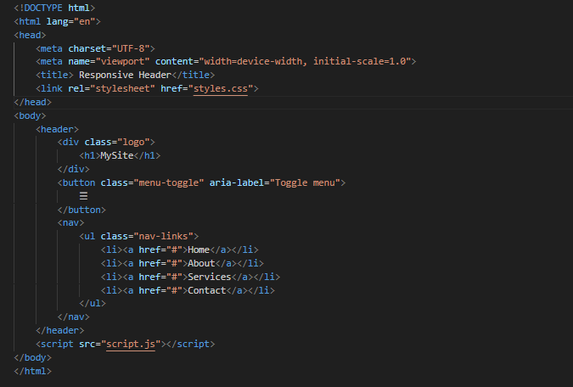

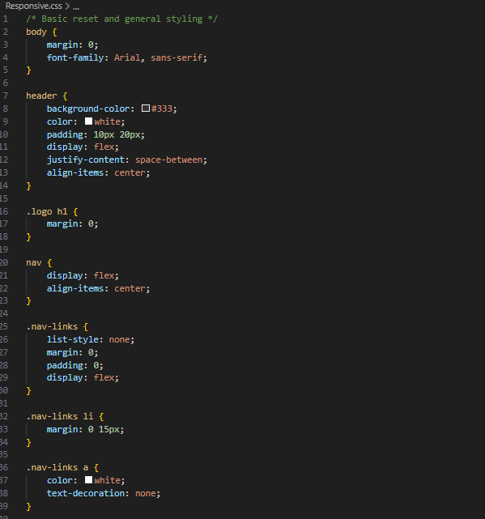

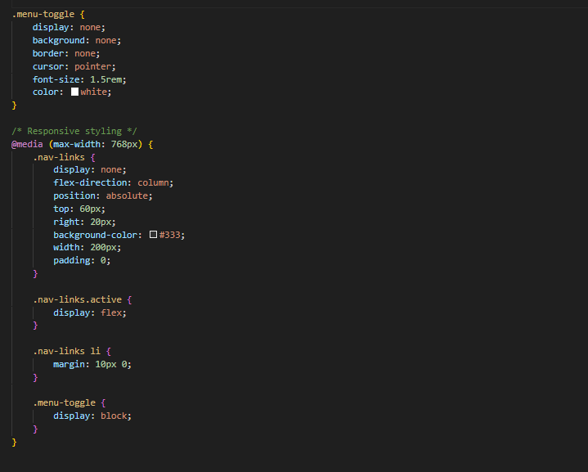

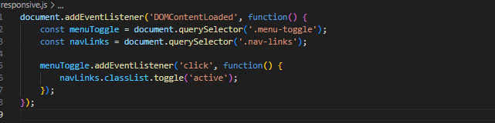

4. Create a form and validate using JavaScript

Ans.

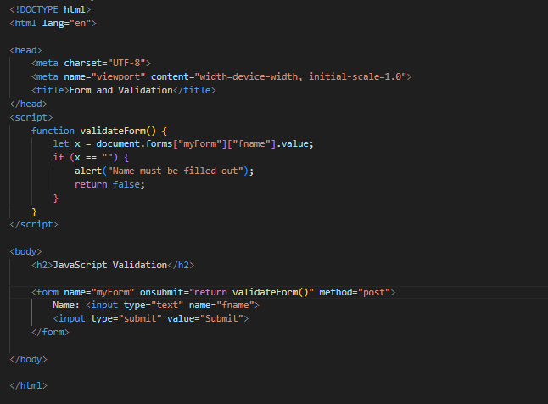

5. Create a modal box using css and Js with three buttons

Ans. 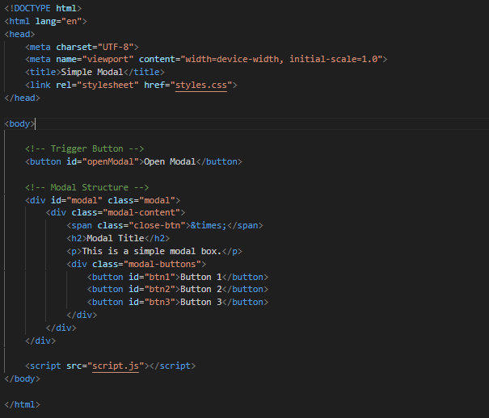

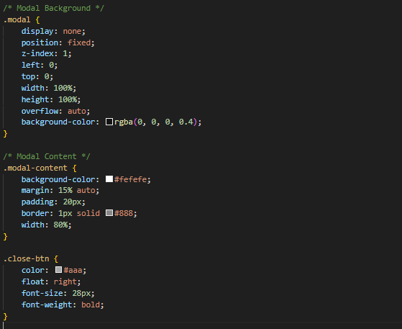

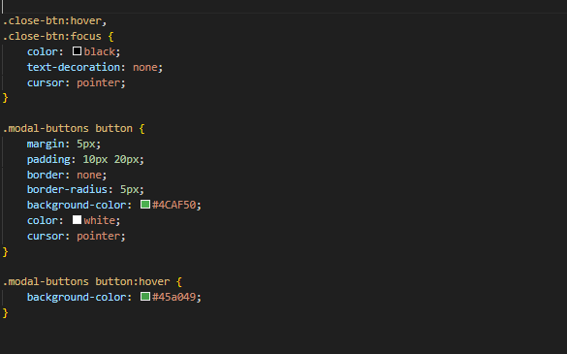

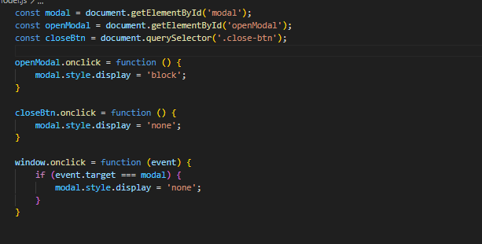

6. Use external js library to show slider

Ans. 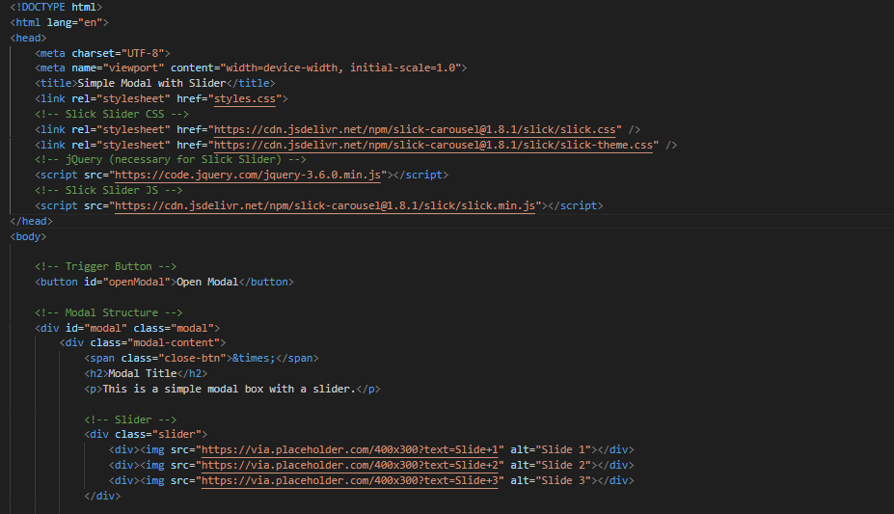

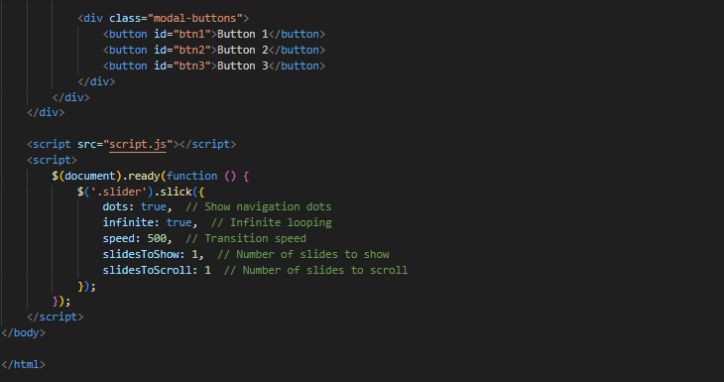

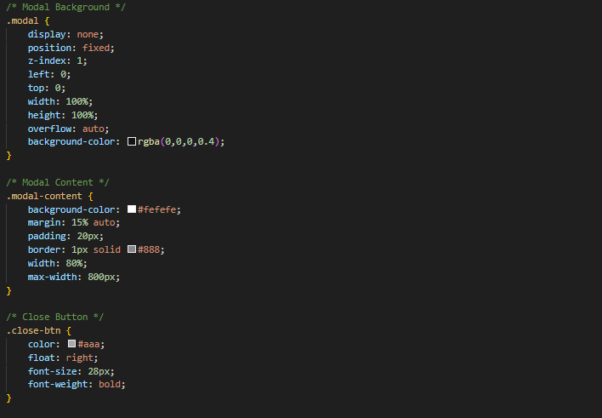

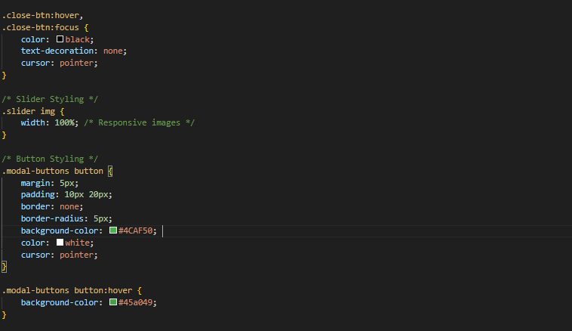

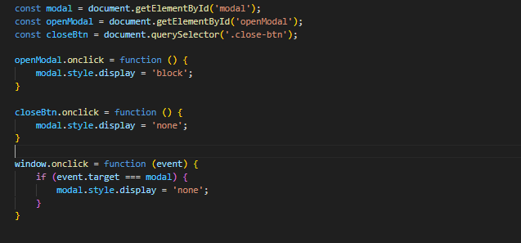

7. Prevent the browser when i click the form submit button

Ans.

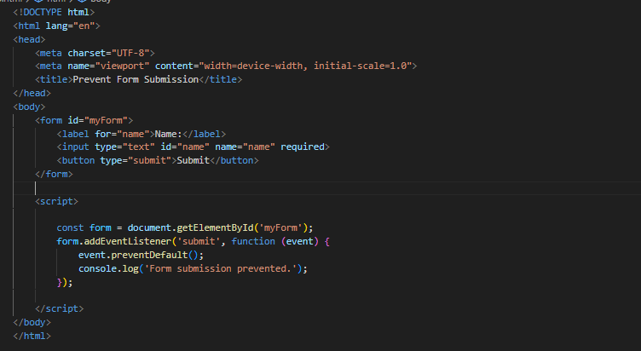

**MODULE: 4 (New Request)**

1) What is JSON

Ans. JavaScript Object Notation (JSON) is a standard text-based format for representing structured data based on JavaScript object syntax. It is commonly used for transmitting data in web applications.

(e.g., sending some data from the server to the client, so it can be displayed on a web page, or vice versa).

{

"name": "hitesh",

"age": 23,

"email": "hitesh@gmail.com",

"isStudent": false,

"address": {

"street": "2 – D Samarpan Apartment",

"city": "Ahemdabad",

"country": "india"

},

"hobbies": ["reading", "playing cricket", "photography"]

}

2) What is promises

Ans. Promises are a way in JavaScript to handle asynchronous operations. They represent a value that might not be available yet but will be resolved at some point in the future. They are a cleaner way to write asynchronous code compared to using callbacks, allowing better error handling and chaining multiple asynchronous operations together. Promises have three states: pending (initial state), fulfilled (successful completion), or rejected (failed completion)

3) Write a program of promises and handle that promises also

Ans.

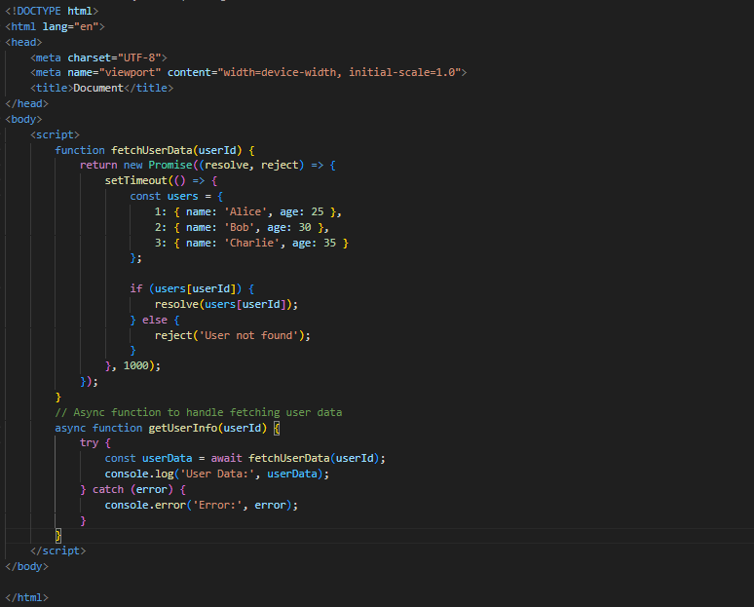

4) Use fetch method for calling an api<https://fakestoreapi.com/products>

Ans.

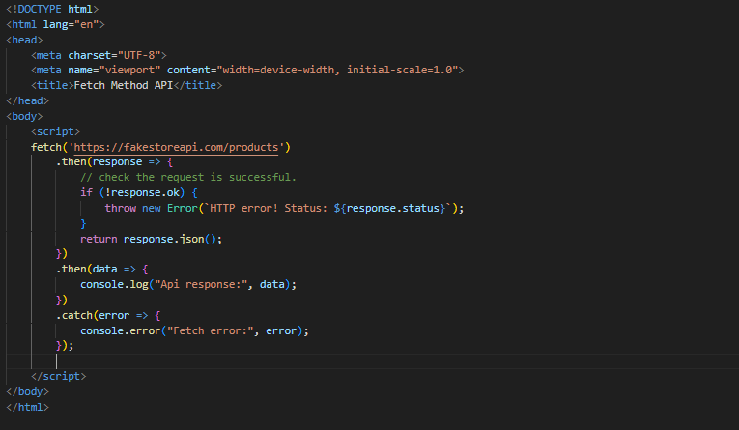

5) Display all the product from the api in your HTML page.

Ans.

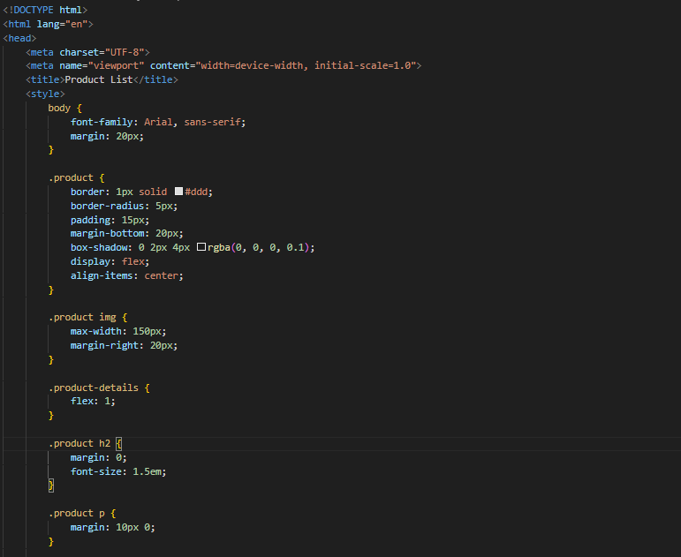

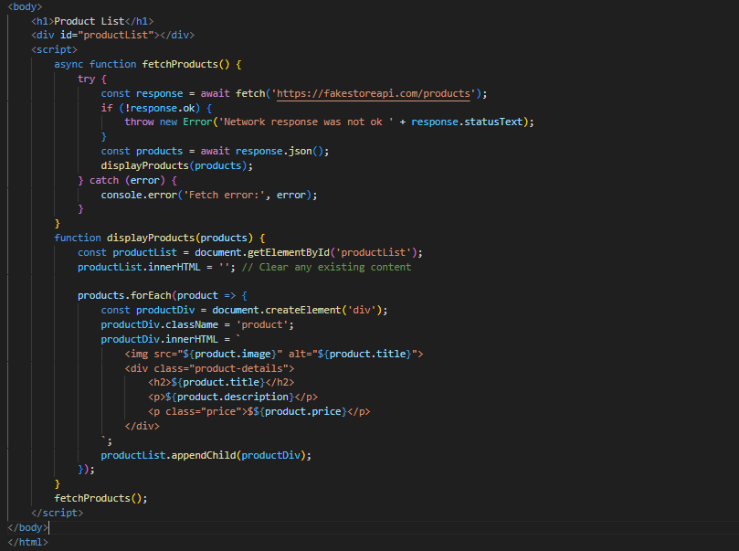

**MODULE: 5 (Javascript Essential)**

1) Calculate subtotal price of quantity in JavaScript?

Ans. 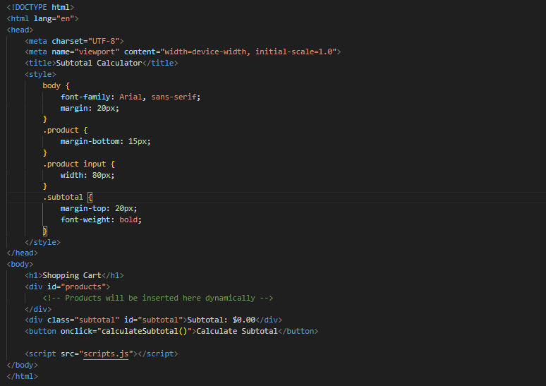

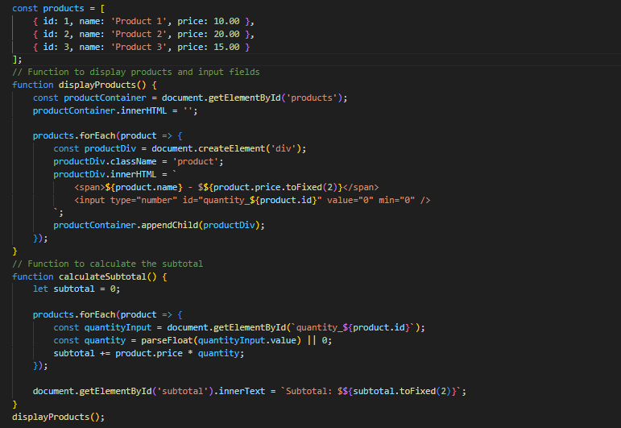

2) What is JavaScript Output method?

Ans. JavaScript doesn't have a specific "output method" in the same way some other languages do. However, JavaScript is commonly used to manipulate and interact with the Document Object Model (DOM) of a webpage, and this interaction often involves displaying output to the user. The primary methods for output in JavaScript include:

1. console.log(): This method is used for logging messages to the browser console. It's commonly used for debugging purposes.

console.log("Hello, world!");

1. DOM Manipulation: JavaScript can dynamically manipulate the content of an HTML document by interacting with the DOM. For example, changing the text content of an HTML element:

document.getElementById("exampleElement").innerText = "New Text";

or appending HTML content:

document.getElementById("exampleElement").innerHTML = "<p>New HTML content</p>";

3) How to used JavaScript Output method?

* Using JavaScript to output information typically involves using **console.log()** for debugging or updating HTML content through the DOM for user-facing output.

Here's an example of using console.log():

console.log("Hello, world!");

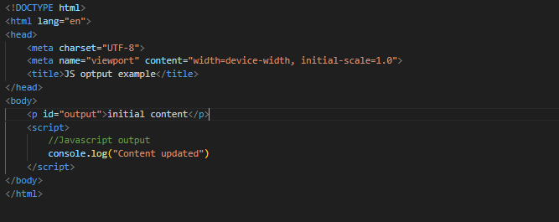

4)How to used JavaScript Events to do all examples?

Ans. JavaScript events are actions or occurrences that happen in the browser, such as a user clicking a button or resizing the window. You can use events to trigger JavaScript code. Here's an example of using JavaScript events:

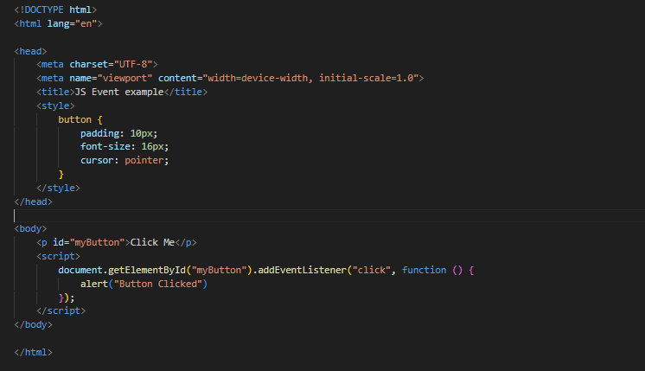

In this example:

* The HTML button element has an ID of "myButton."
* The JavaScript code uses addEventListener to listen for a "click" event on the button.
* When the button is clicked, the provided function is executed, showing an alert with the message "Button clicked!"
* This is a basic example, and JavaScript events can be used for a wide range of interactions, such as handling form submissions, responding to keyboard input, and more